Customer Behaviors Analysis

Project Overview
This project analyzes customer shopping behavior using transactional data from 3,900 purchases across various product categories. The goal is to uncover insights into spending patterns, customer segments, product preferences, and subscription behavior to guide strategic business decisions.
Dataset Summary
- Rows: 3,900
- Columns: 18
- Key Features:
• Customer demographics : Age, Gender, Location, Subscription Status.
• Purchase details : Item Purchased, Category, Purchase Amount, Season, Size, Color.
• Shopping behavior : Discount Applied, Promo Code Used, Previous Purchases, Frequency of Purchases, Review Rating, Shipping Type.
- Missing Data: 37 values in Review Rating column
Objectives:
- Extract raw data

- Perform ETL

- Load to MySQL

- Connect Power BI

- Build dashboards

Dataset Columns:
customer_id, age, gender, item_purchased, category, purchase_amount, location, size, color, season, review_rating, subscription_status, shipping_type, discount_applied, previous_purchases, payment_method, frequency_of_purchases, age_group, purchase_frequency_days

Business Objective:
Provide actionable insights about customer behaviour for an e-commerce retail organisation.
Stakeholders:
Analytics, Marketing, Product teams, Operations.
Key Business Questions:
• Active customers → Number of Customers
• Average transaction value → Avg Purchase Amount
• Customer satisfaction → Avg Review Rating
• Subscription revenue split → Subscription Status Metrics
• Category-level performance → Revenue & Sales by Category
• Age-based metrics → Revenue & Sales by Age Group
• Delivery efficiency → Shipping Type Analysis

KPIs:
.*What is the total revenue generated by male and female customers?
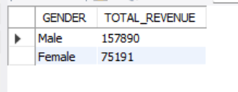
* Which customer used a discount that still spent more than the average purchase amount?
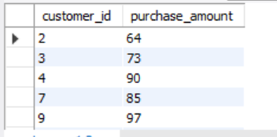

*which are the top 5 product with the highest average review rating?
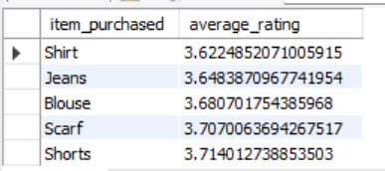

* Compare the average purchase amounts between standard and Express shipping?
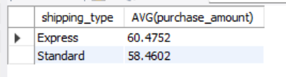

*Do subscribed customers spend more and compare average spend and total revenue between subsciber and non subscriber?
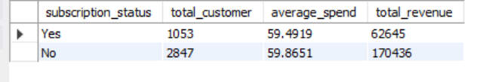

* Which 5 product have the highest percentage of purchase with discount applied?
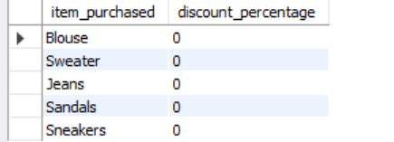

*Segement customer into new , returning and loyal based on their total number of previous purchase and show the count of each purchase?
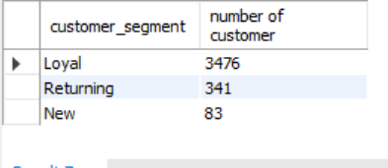

* what are the top three most purchased products within each category?
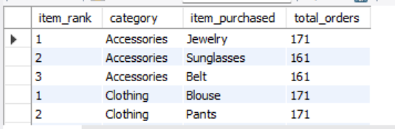

* Are customers who are repeat buyers (more than 5 previous purchases) also likely to subscribe ?
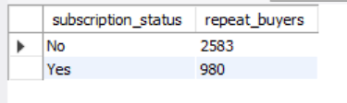

* what is revenue contibution of each age group ?
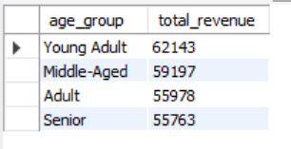

Visual Recommendations:
KPIs, donut charts, column charts, slicers.
Color Theme:
Coral (#FF6F61), Purple (#6B5B95), Green (#88B04B), Light Pink (#F7CAC9), Soft Blue (#92A8D1).
Data Notes:
Clean data, normalize categories, handle missing values, derive new fields.
Refresh & Access:
Daily/weekly refresh, Power BI connects to MySQL.
Deliverables:
README, Business Brief, Data Dictionary, Theme file, Dashboard mockup.
Power Bi Dashboard
